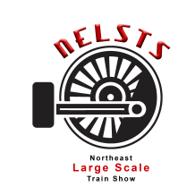
Amherst Railway Society’s Northeast Large Scale Train Show
Wait List Application
Please email to showoffice@amherstrail.org or mail to PO Box 247 Monson MA 01057.

NEW OR UPDATE
Exhibitor’s Name:
Mailing Address:
City/State/Zip:
Phone Number:
Web Site:
MA Tax ID #:

Contact Name:
Email Address:
Home Phone:
Cell Phone: |  | Other Phone (Type?):

Notice Required (1 day, 2 days, 1 week, 1 month?):
How did you hear about our Show?
Are you a returning vendor?

Vendor Questions
What do you sell?
What scale(s) or gauges?
Number of Tables Requested:

Layout Questions
Layout Size:
Scale or Gauge:
Describe or attach a picture:
Do you use barrier?

Non-Profit Questions
Number of Tables: | Sales: | Non Sales:
Please attach an IRS Letter of Determination.

